SE E-Journal

Pr. No | Practical Name | Page No.
1. | User Story | 2
2. | Creating Scrum board using Trello | 5
3. | Drawing Burndown Chart | 6
4. | Git Commands | 7
5. | Git Branching | 10
6. | Refactoring | 11
7. | Junit Testing | 14
8. | Selenium Automated Testing | 17
9. | Debugging | 19
10. | Generating Java Docs | 20

User Stories
- User Stories for an Online Mega-store:

- REGISTER PAGE:
- As a user
I want a register page
So that I can be a registered user of that store which will make my buying process much easier
Acceptance Criteria:
- Given that I am not registered in that online store already
- When I click on sign up/register and click on the submit button after filling in the details
- Then I am a registered user in that store

- LOG IN/SIGN UP/LOG OUT
- As a registered user
I want a login/logout option/icon
So that If I log in to a public system My data won’t be there any longer once I log out
Acceptance Criteria:
- Given that I have logged into a system with the correct username and password
- When I click on the logout option
- Then I come out of that website with my data not stored in that system

- HOMEPAGE
- As a Registered user
I want a homepage
So that it holds the information of most of the offers available at that moment and all other icons that are related to some other options that are used in the online store
Acceptance Criteria:
- Given that the home page has a navigation bar and sidebar
- When I click on the options I am redirected to functions of the options held in the navigation bar and sidebar and the home page will have the list of offers available and the list of recently browsed items
- Then I can buy the items desired by me and possibly at a discounted offer

- NAVIGATION BAR ICONS
- As a registered user
I want various icons on one side or a navigation bar
So that it holds categories, profiles, Wishlists, Payment, and order tracking.
Acceptance Criteria:
- Given that the homepage has a navigation bar and sidebar
- When I click on any of the icons
- Then I am redirected to the pages where the function of the said icons is put to work

- CATEGORIES
- As a registered user
I want one icon for categories
so that it makes searching easy for a particular item
Acceptance Criteria:
- Given that there is an icon made specifically to list the categories based on various criteria (i.e gender, clothing, age, footwear, electronics)
- When I click on them I can surf through them easily
- Then my time to search for the desired item is reduced to half

- TRACKING ORDERS
- As a registered user
I want one icon for orders
So that it has the information about the products that I have bought in the past and will also have the information tracking the order
Acceptance Criteria:
- Given that there is an icon made for the order tracking
- When I click on that icon
- Then I can track my upcoming orders and have the data of what I have bought over time

- PROFILE PAGE
- As a registered user
I want one icon for my profile
So that I can update my personal information whenever I want.
Acceptance Criteria:
- Given that there is a special icon for the profile
- When I click on that icon all the personal detail is displayed on that page
- Then I can update the address or name if I have entered it wrongly

- WISHLIST
- As a registered user
I want an icon for the Wishlist
So that I can put the item in it and buy them later
Acceptance Criteria:
- Given that there is a wishlist icon
- When I click on that I am redirected to a page that holds the lists for wishlists
- Then I can buy the items that I have added to my wishlist before

- SEARCH BAR
- As a registered user
I want a search bar
So that I can search for any desired item
Acceptance Criteria:
- Given that the item should be present in the store
- When I search for it if it is not available or out of stock
- Then the store should show similar items to my search

- PAYMENT
- As a registered user
I want an option for different ways of payment
So that I can have different options while buying things like online payment or cash on delivery.
Acceptance Criteria:
- Given that there are secure payment options
- When I try to pay through them
- Then the payment should be successful

Creating a Scrum board using Trello
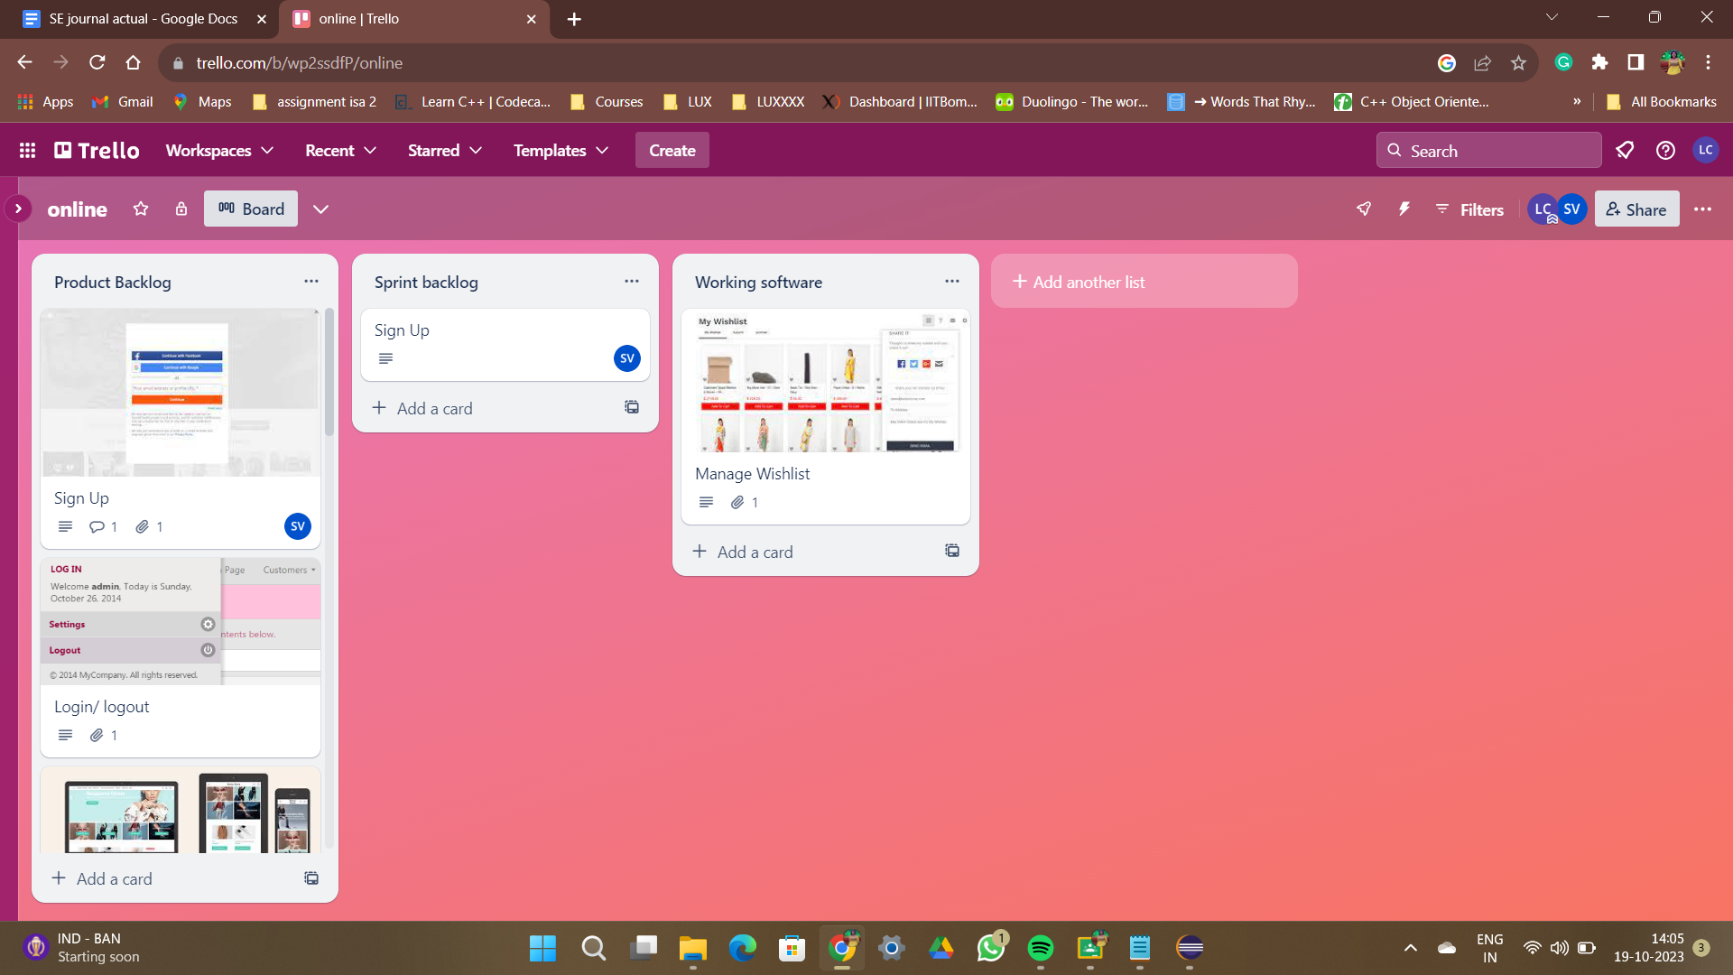

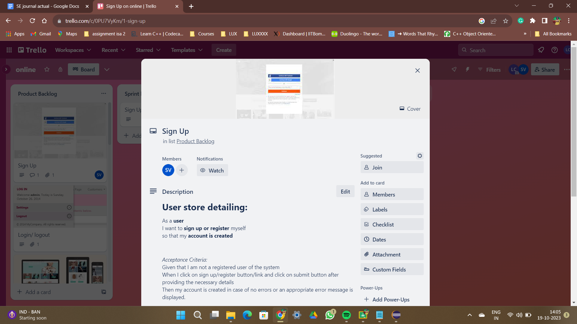

Drawing Burn Down Chart
Step 1: Create a table in Excel.
Step 2: Fill the data.
Step 3: Use the formula and find the total hours and actual number of hours remaining and estimated number of hours remaining.
Step 4: Select the actual number of hours remaining and estimate number of hours remaining and make a burndown chart.
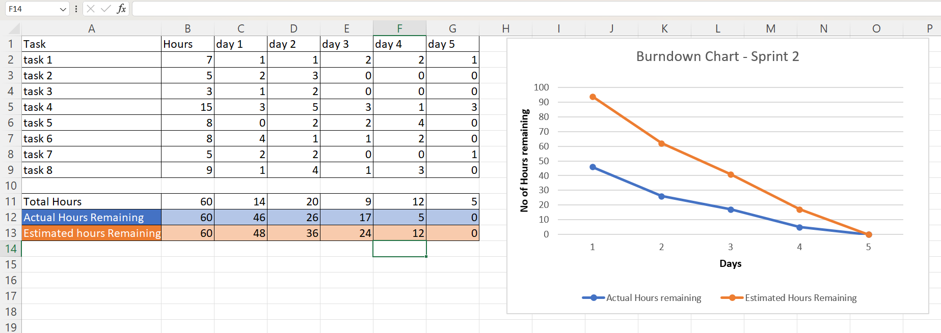

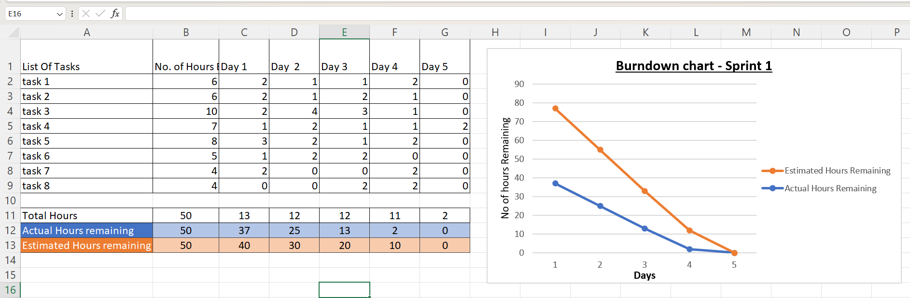

Git Commands
  - git → to check if the git package is present on the system or not
  - git --version →To check version
  - sudo apt update → to update the system
  - sudo apt install git → to install git package
    - Broken Installation:
      - sudo apt --fix-broken install
      - sudo apt install git
    - Successful installation
  - git --version
  - Initialize the settings locally (configuring username and email)
git config --global user.name “laxmi1763”
git config --global user.email “charilaxmi1@gmail.com”
git config --list → to see global config

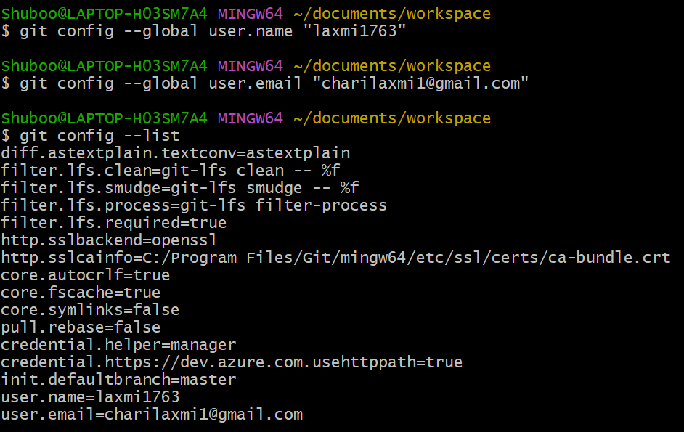

  - Integrate local environment with GitHub
  - Login to your GitHub account
  - Create a repository
  - In Ubuntu create a directory (named workspace)
  - Execute the git clone command
git clone ‘…link of the repository…’

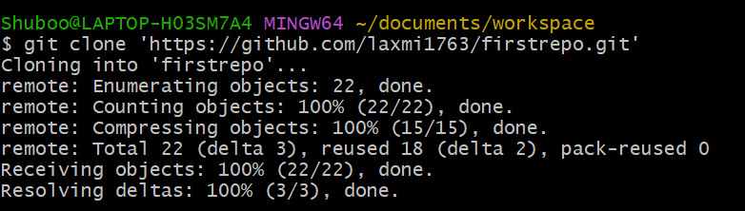

  - Navigate to the repository locally in Ubuntu
cd repositoryname
  - Create a Python code file
touch first.py
  - git status → shows the untracked file first.py
  - git add first.py → If 2 files git add 1.txt 2.txt → adds files to the staging area and the file would be committed together to the remote repository
  - git status → shows the files added to the staging area

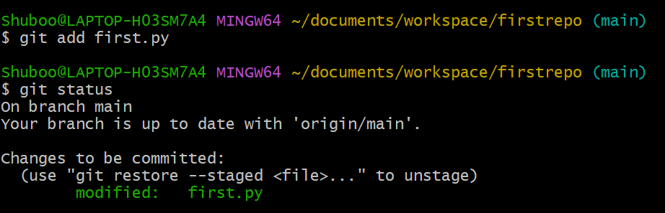

  - Commit
git commit -m “Python program committed” → used when more than 1 file is added to the staging area and then commits them altogether
git commit first.py -m “first.py committed” → In case only one file is to be committed

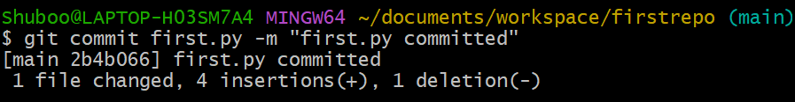

  - Push Local changes to the remote repository
git push origin master main
Generate token
git remote set-url origin https://…generated_token…@github.com/username/repositoryname
Git push origin main

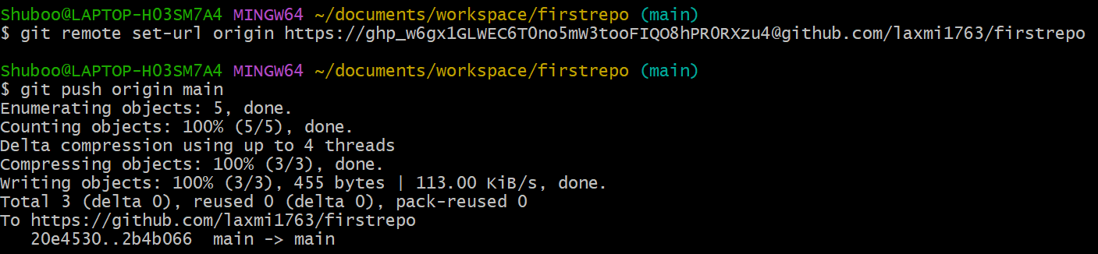

Git branching
  - git branch branch-name →creates the branch
  - git branch -a → to list the branches
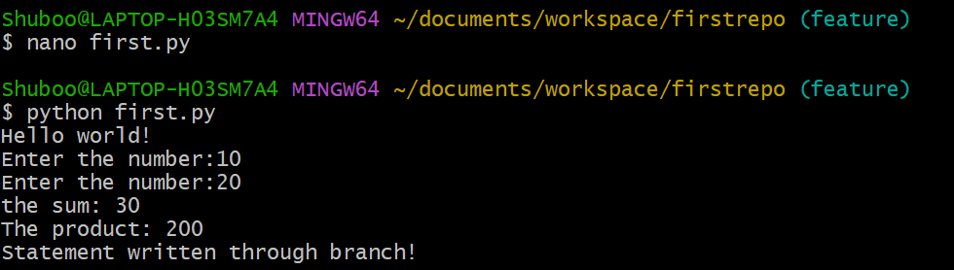
  - git checkout branch-name →to check out from the created branch and to go to the main branch
  - git status
  - git merge branch-name →to merge main and target branch
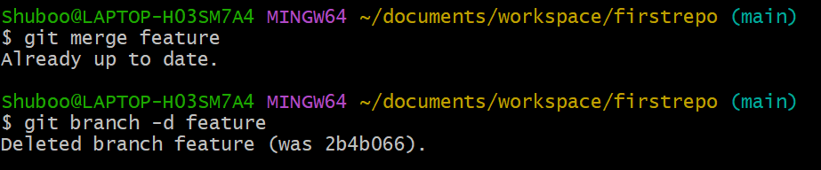
  - git branch -d branch-name →to delete the obsolete branch after merging

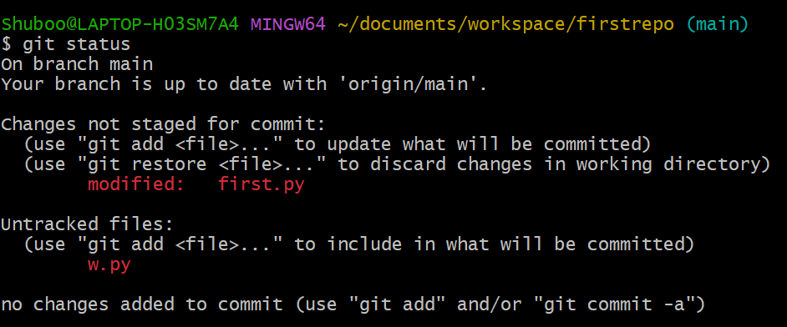

Refactoring
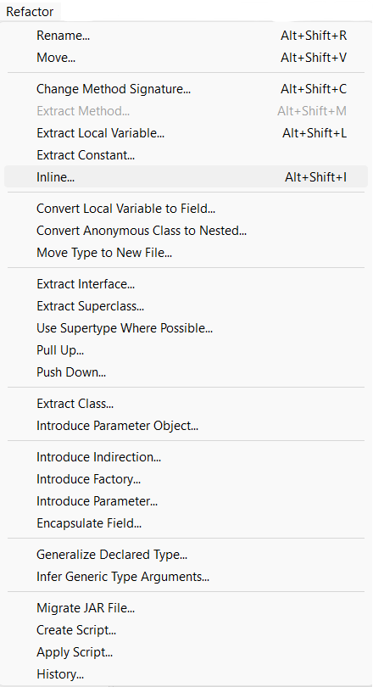
  - Rename:
Select variable/class name/method name
→Right click→refactor→rename.

  - Extract Method:
Select relevant code
→Right click→refactor→extract method.

  - Inline:
Select relevant code
→Right click→refactor→inline.

  - Extract Local Variable:
Select relevant code
→Right click→refactor→extract local variable.

Refactoring II
  - Extract Constants:
Select relevant code
→Right click→refactor→extract constants

  - Change method signature:
Select method name
→Right click→refactor→change method signature→add

  - Move method:
Select the entire method
→Right click→refractor→move→click on browse→choose the new class→ok

  - Extract Superclass:
→Create 2 classes: circle and rectangle.
→Circle with data members' colour and radius
→Rectangle with data members length, breadth and colour
→Right click→refractor→extractSuperClass→click on Add (choose appropriate
class) →Click on add and select parameters→ok.

Junit Testing
Procedure:
Step1: Click on the file menu and select project
Step2: Right-click on the project and create a class (e.g., circle)
Step3: Declare a data member (e.g., float radius)
Step4: Right-click on class i.e., circle ->go to source->click on generate getters and setters
Step5: Create a function i.e., area (implement the function)
Procedure:
Step1: Click on the file menu and select project
Step2: Right-click on the project and create a class (e.g., circle)
Step3: Declare a data member (e.g., float radius)
Step4: Right-click on class i.e., circle ->go to source->click on generate getters and setters
Step5: Create a function i.e., area (implement the function)
Circle Class:
package junit;
public class Circle {
public float radius;
public float getRadius() {
return radius;
}
public void setRadius(float radius) {
this.radius = radius;
}
public float area() {
return (float)(3.14 * this.radius * this.radius);
}
}

Step6: Right-click on package ->click new->click on Junit
Step7: Write the class name for the Junit test case and browse the class i.e., circle
Step8. Click the next button right down the window
Step9. Select all the methods on which you want to write the test cases i.e. set radius () and area()
Step10: Create an instance of a class which functions are to be tested
Circle Testcase class:
package junit;
import org.junit.jupiter.api.Test;
import junit.framework.TestCase;
class CircleTestCase extends TestCase{
@Test
void testSetRadius() {
Circle circle = new Circle();
circle.setRadius(2.0f);
assertEquals(12.56f,circle.area());
}
}

Step 11: Run test case class i.e. Right click on test case class and click on Run as ->Junit

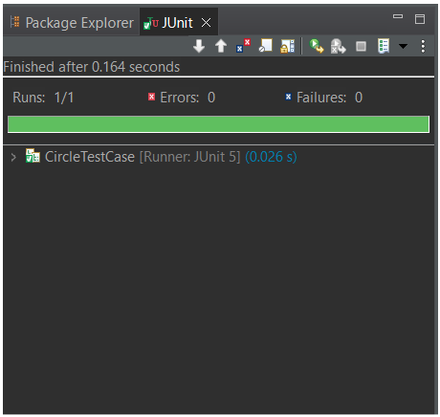

To run one or more test cases together we create a suite:
Right-click on package-> new-> other-> Java-> Junit-> Junit Suite Browse the package name in which classes are created Select all the test case classes that need to be run -> Click Finish

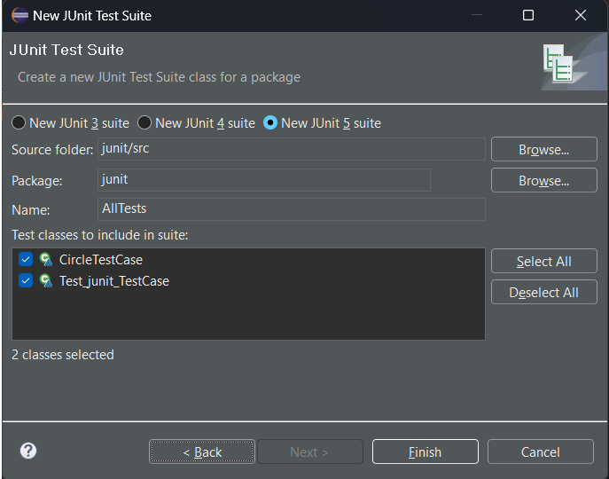

To execute: Right Click on suite class (All Test) -> Run it as Junit

Selenium Automated Testing
Selenium code:
package assignSeleniumWeb;
import org.openqa.selenium.By;
import org.openqa.selenium.WebDriver;
import org.openqa.selenium.WebElement;
import org.openqa.selenium.chrome.ChromeDriver;
public class ClassLocator {
public static void main(String[] args) throws Throwable {
System.setProperty("webdriver.chrome.driver", "C:\\Software\\chromedriver-win64\\chromedriver.exe");
WebDriver driver=new ChromeDriver();
//to maximize the window
driver.manage().window().maximize();
driver.get("https://github.com/login");
WebElement email = driver.findElement(By.id("login_field"));
email.sendKeys("charilaxmi1@gmail.com");
WebElement pass = driver.findElement(By.name("password"));
pass.sendKeys("lakshmi_2003");
//log-in button
driver.findElement(By.name("commit")).click();
//adds delay for 10 seconds
Thread.sleep(10000);
//to close the browser
driver.quit();
}
}
Output:
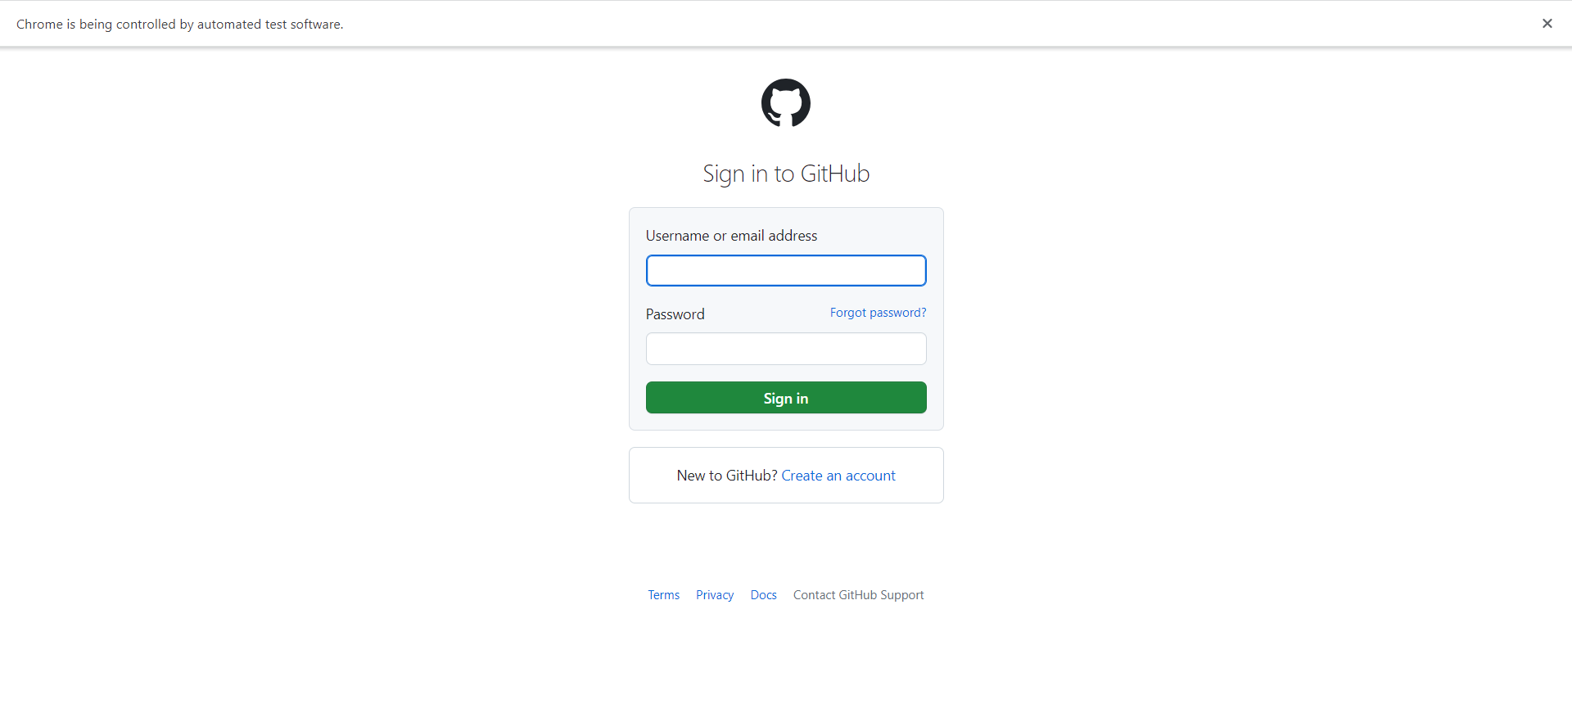

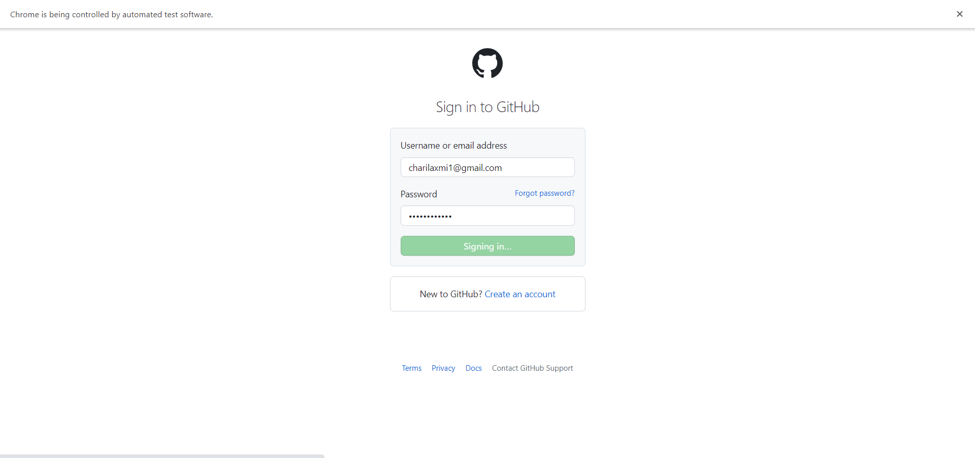

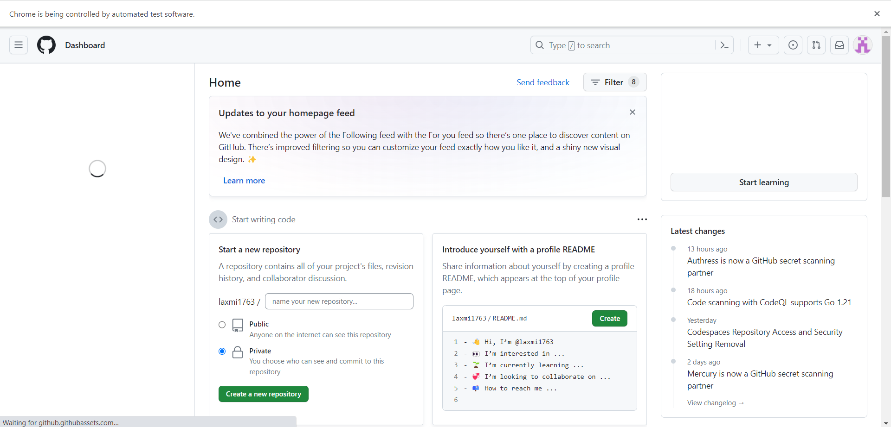

Debugging
Step 1: insert toggle breakpoints on the code form in which you are getting errors or want to start debugging.
Step 2: click the debug button.

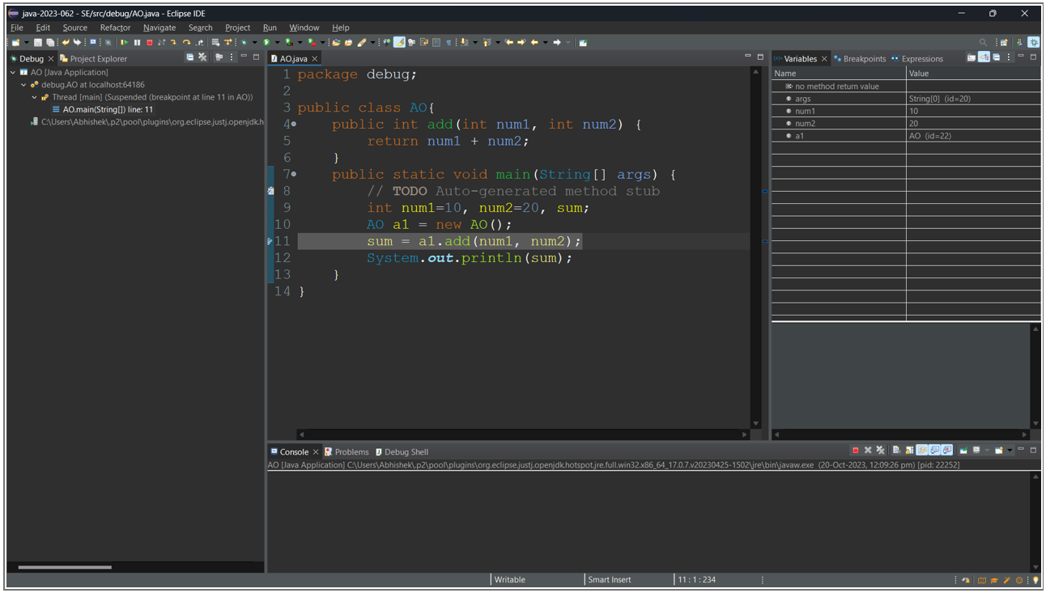

Navigation for debugging:
- F5: is used to jump into function
- F6: is used to jump next line
- F7: is used to jump out of the function
- F8: is used to jump to the next toggle breakpoint

Generating java documentation
Step 1: Select your project click on a project on the menu bar and select Generate
Step 2: Click on the project name, give the destination path for saving Javadoc and click finish
